

The Shell Petroleum Development Company of Nigeria

Bonny Node NAG Multi-Rate Test Report

|  |  |  |  |
| --- | --- | --- | --- |
| Document Number: |  | Prepared by: | Emmanuel, Mogbolu – Reservoir Engineer  Epebiyi, Taiwo – Process Engineer  Udobata, Uchenna- Production Technologist  Iya, Ann – Production Technologist  Iheanyi, Eke – Production Chemist  Pius, Akpaibor – Snr. Programmer |
| Document Owner: |  | Version | 1.0 |
| Issue Date : |  | Review Date: | April 2017 |
| Record Type Name: | Reservoir & Well Data | Record Series  Code: |  |
| Security  Classification: | Restricted | ECCN  Classification:  Retention: | Not Subject to EAR – No US Content  EVT+ 15 |

**Table of Authorization**

|  |  |
| --- | --- |
| Reviewed/Agreed By: | Signature/Date |
| Ndukwe Agwu  UPO/G/DNC  Production Technology TA3/ Soku FMT Lead |  |
| Magnus Amaefuna  UPO/G/DNC  Bonny Nodal FMT Lead |  |

|  |  |
| --- | --- |
| Reviewed/Agreed By: | Signature/Date |
| Nwankwo Comas  UPO/G/DN  Production Technology TA2 |  |
| Nkonye Oghene  UPO/G/DN  Reservoir Engineering TA2 |  |
| Bamidele, Taiwo  UPO/G/PSC  PC TA1 |  |

**Introduction:**

Multi Rate Test (MRT) for Gas wells is a key requirement for good WRFM practice. It is used in determining gas well deliverability in order to provide the business with credible promise from the gas wells and optimize investment gains. Well deliverability is also a key component to determining the outflow expected from a gas well in order to guide intervention on the well during a safety incident of loss of well containment. The standard method for carrying out MRTs in gas wells is by mobilizing a temporary separator, however, due to budget constraints, community unrest & safety considerations the asset team in collaboration with the operation team decided to carry out MRT on its gas wells using available equipment at the Bonny NAG Plant.

This was a pilot phase that was targeted to utilize the Gas Plant as a giant test separator for the individual test. Furthermore, test by difference was the agreed strategy for the low gas producers. The results of this exercise were analyzed and found to be representative of the parameters expected from a standard MRT test. This report documents the methodology, results, analysis and limitations of the exercise.

**Business Case:**

To conduct a Multi-Rate Test using the standard mobile test separator, an approximate cost of US$2ml per gas well is required. Hence, for 6 wells, this amounts to **US$12mln**. Hence, utilization of the existing facility in place to conduct these tests not only averts the needs to incur this cost, but it achieves **zero deferment** in gas supply through optimal test execution in line with gas nomination requirements**, zero gas flaring** as gas from the mobile test separator is typically flared and ultimately, **lower HSSE exposure** of the well test crew.

**Objective of the Multi rate Test:**

The objective of the MRT for the 6 Bonny Node NAG wells is to determine deliverability of the wells, the productivity index(PI), estimate the Skin from each well and comply with the statutory requirement of testing SPDC NAG wells once every year. The Multi Rate Test is important because it helps understand the dynamics of the well & reservoir, helps in estimating realistic potential of SPDC NAG wells, potentials are fed into business planning and new gas development as analogues. The MRT is also used to estimate the Absolute Open Hole Flow potential of each well in order to guide well interventions on the volume of outflow expected from each well during a situation of total loss of control of the wells. In addition, the multi rate rest is a four-point test carried out at a series of different flow rates for the purpose of reservoir characterization, evaluating skin from well completion, reservoir permeability and distance to reservoir boundary.

Furthermore, Bulk flow testing was carried out to obtain BNAG deliverability in full operation mode. It will also be used to update the IPSM to a more representative operational mode for opportunity optimization

**Multi rate tests Methods in gas wells**

Several multi rate test methods have been developed to collect the data for use with the basic deliverability models. These tests can be divided into three basic categories:

*Flow-after-flow tests (Rawlins and Schellhardt1)*

The test consists of a series of flow rates. The test is often referred to as a four-point test. This test is carried out by flowing the well at a series of stabilized flow rates and obtaining the corresponding stabilized flowing bottom hole pressures. In addition, a stabilized shut-in bottom hole pressure is required for the analysis. A major limitation of this test method is the length of time required to obtain stabilized data for low-productivity/ permeability gas reservoirs (which does not apply to Bonny Node reservoirs). This is the type of test selected for the Bonny Node gas wells.

*Isochronal test (Cullender, 1955)*

This method was proposed by Cullender to optimize the flow after flow method of stabilized flow rates from slow to stable well flow. The test procedure involves producing the well at different flow rates at specified equal duration separated by closed in periods where the closed in bottom hole pressure is allowed to stabilize at the average reservoir pressure. This procedure requires a longer flow point to be achieved .One disadvantage is that its takes a longer time to achieve pressure stabilization in low permeability gas sand during the closed-in period between flows. The test method is based on the principle that the radius of investigation is a function of the flow period and not the flow rate. Thus, for equal flow periods, the same drainage radius is investigated in spite of the actual flow rates.

*Modified isochronal test (Katz et al, 1959)*

Due to time required to obtain stabilized shut in pressure in tight reservoir wells Katz et all proposed a modification to the isochronal test by requiring equal shut in periods. Though the modified isochronal is same as the isochronal test however the shut in periods are equal to or longer than the flow periods. The modified isochronal is less accurate than the isochronal because the shut in pressure is not allowed to return to the average reservoir pressure.

|  |  |
| --- | --- |
|  |  |
| *Figure 1: Evaluation of four point test data (after Jones, Blount and Glaze).* | *Figure 2: Well Skin sensitivity* |

The recorded bottom hole flowing pressure recorded at different flow rates during any of these test is then interpreted. Figure 1 shows the Cartesian plot of ΔP/q against rate generated from the test data. The intercept (a) gives a qualitative indication of Darcy skin and or permeability while the slope (b) defines the turbulence factor or non-Darcy skin coefficient. Figure 2 shows skins sensitivity for different well scenario. Figure 2 is best used when comparing result for different well in a reservoir. Case 1 show zero slope (b = 0) hence no turbulence. The turbulence increases in Cases 2 and 3 (b > 0). Case 2 and 3 turbulence can be reduced by decreasing the flow rate and increasing shot density/ perforation interval respectively. Also, note that Cases 1, 2 & 3 have low Darcy skin (Skin due to damage) or high permeability because of the low intercept on the y axis. Case 4 shows zero slope and high intercept on the y axis hence a high Darcy skin or low permeability and no turbulence. The high Darcy skin in the vicinity of the well can be improved by stimulation. Case 5 shows high Darcy skin and high non Darcy skin or turbulence. Wells in this category should be considered for stimulation and re-perforation to improve performance.

The last MRT done in Bonny was in 2014, though it did not cover all the gas wells based on cost. The test had limitations based on the mobile test separator’s capacity limitation. It was therefore required to calibrate current performance of producing wells with a well model. The business needed to determine the gas well potentials and explore optimization of the BNAG wells. In addition to this, the condensate and current CGR data for the wells were needed for robust WRFM compliance. Furthermore, due to budgetary limitations, security risks and environmental conditions standard MRT via a test separator could not be carried out, it was required to use alternative method to carry out the MRT. Statutory WRFM MRT compliance had also been an exposure, though this has been majorly due to budget. This report contains the results from the alternative MRT procedure of testing the wells via the Gas Plant and the results obtained from this analysis. Also highlighted are the limitations of using this methodology.

**Methodology:**

The two traditional methods available for Multi rate testing in SPDC is multi rate test via a third party separator and Multi rate test via a separation facility.

*Mobile Test Separator*

The Multi rate test via a third party separator starts with deployment of downhole gauges into the well via wireline for downhole measurements of pressure and temperature. The well is now connected to a Mobile separator unit (figure 3a &b) and exit of the separator connected back to the central processing facility. The well fluid flows into the test separator and gets separated into gas and liquid. The gas is flowed through an ultrasonic gas flow meter and regulated with a control valve. The liquid is also flowed through a Coriolis liquid meter where flow rate and water cut of liquid sample is measured. The flow from the gas and liquid is recombined at the end of the process and evacuated to the Central processing facility. For different rate steps depending on the MRT program the rate of the well is varied and FTHP, FTHT, WGR, CGR and FBHP are recorded. The data collected is then used to determine deliverability of the well, PQ curve, Productivity Index, Skin, Permeability of the reservoir and ultimately satisfy statutory requirements. This method is regarded as the most reliable as the date is measured directly however it has limitations in terms of getting to the required well potential and considerations around associated gas flaring. In addition it is a very expensive methods as it costs average $1M per well. This method also involves more personnel on ground and this introduces HSSE risk.

|  |  |
| --- | --- |
|  |  |
| *Figure 3a : Schematic of MRT via Test Separator* | *Figure 3b : Picture of MRT via Test Separator* |

*Testing Via Gas Plant:*

The MRT method deployed for the Bonny NAG wells is using the existing configuration of BNAG Plant. This method involves producing the wells as they are configured through the BNAG Plant. Figure 4 below summarizes the available concepts that were considered in the development of the methodology utilized for this exercise. As shown, for each parameter of interest, the blue line shows the selected method that was deployed in the Bonny Case as explained thus.

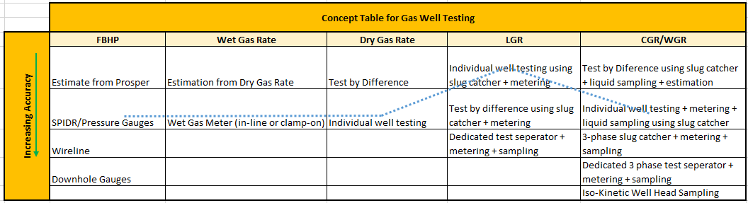

*Figure 4: Concept Table for 2016 NAG Well Testing in Bonny Gas Plant*

The flow configuration of the Bonny Non- Associated Gas Plant is shown below in Figure 5. NAG wells are bulked together which is transported via a 14” x 9.3 km bulkline to the BNAG plant. There is a provision to flow the NAG wells through the main slug catcher and the Bypass Pre-separator at increased flow nominations, At the slug catcher, the gross liquids are separated from the gas stream and each separated stream is metered. The Flow Control Valves downstream the main slug catcher is responsible for flow control into the TEG dehydration unit and these valves respond to increased flow nomination by opening up to achieve nomination. For the purpose of the MRT test, the bypass pre-separator was used as the Test separator to flow each of the individual NAG wells with the main dehydration unit isolated. The flow controller/ valve (81-FQIRC-310/81-FCV-310) on the bypass pre-separator gas inlet line was used to control the flow of gas through the bypass pre-separator and served as a flow restriction to obtain wet gas flowrates at different valve openings. The wet gas rates were measured with the aid of an ultrasonic clamp-on meter located on the inlet lines feeding the 14-inch bulklines. The dry gas rates were obtained from the export meters and liquid rates from the Coriolis meter located on the liquid outlet lines. Liquid samples were also taken at the Plant to determine the LGR and the ratio of condensate to water.

*Figure 5a: Schematic of Bonny Gas Plant*

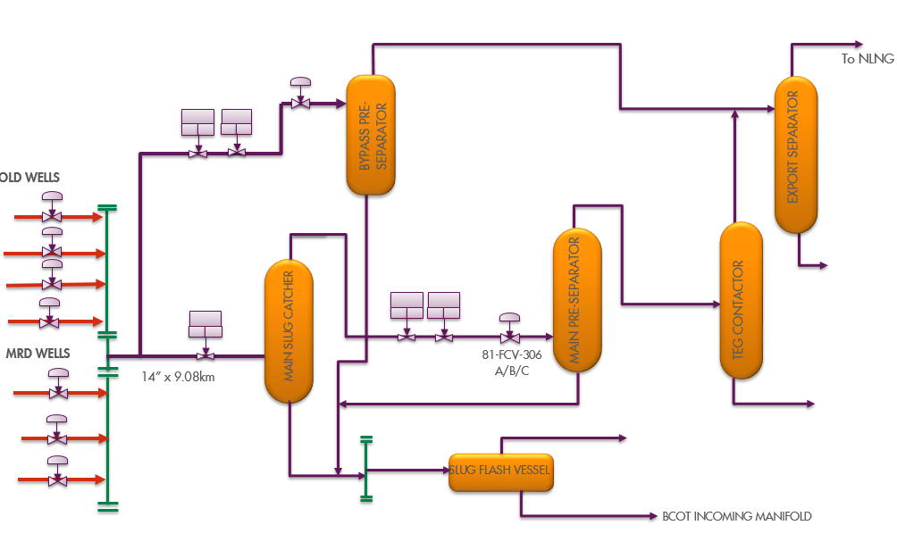

PROSPER was used to generate the FBHP using surface conditions for the tested wells.

The Export meter was utilized to obtain the dry gas rate for each NAG well and liquid gas ratio estimated for each well based on the liquid production data with the gas rate. Using this method, a more representative data set was obtained

Testing by difference was used for BONN023T due to its low rate. The corresponding difference in bulk gas and liquid rate is then used to obtain the liquid gas ratio and the dry gas to wet gas ratio (see figure 5b). To further break down the LGR into CGR and WGR, the liquid samples taken were analysed and the resulting water cut was used to back calculate the CGR and WGR by difference. However, due to static settling effects within the slug catcher, the calculated CGRs and WGRs were only accurate for dry systems. Proposed solutions to limitations such as this are documented in the ‘Limitations and Recommendations’ section of this report.

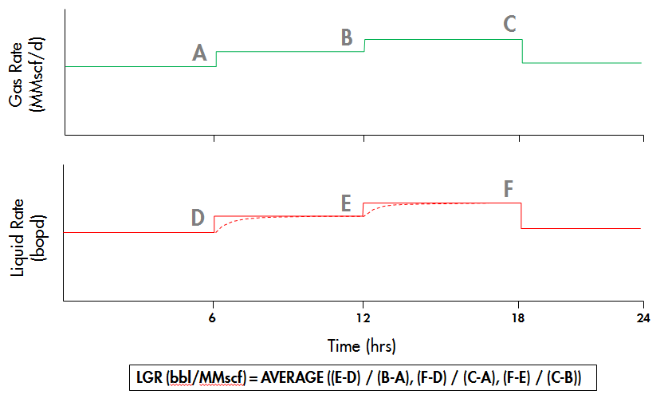

*Figure 5b: Test by difference to determine Liquid Gas Ratios.*

Advantages of the MRT via the Plant include zero cost as nothing was paid for, less personnel on site (zero HSSE risk), utilizing NLNG maintenance window effectively (minimum deferment), Zero gas flaring and no limitation to the maximum gas flow rate to be explored.

**Results:**

This report is focused on the detailed analysis of the MRT testing via Bonny Gas Plant carried out on BONN025T. In addition, a summary of the analysis carried out on four other NAG wells producing to the Bonny Gas Plant. BONN025T is one out of 6 NAG wells currently flowing to the Bonny Gas Plant. All the wells were selected for MRT due to the radical change in potential since 2014, to obtain their current potentials. Furthermore, the result will be used for 2017 ARPR evaluations as well as adhering to statutory requirements. BONN025T was drilled in August 2009 …….. The well was completed with 7” 13Cr tubing with EGP as sand control and PDHG installed. The MRT analysis is expected to evaluate the reason for this decline and advise management on the realistic potential to assign to this well in order to evaluate ability of the company to meet Gas contractual demands. This analysis is also essential to determine the permeability, skin and Productivity Index of the well. See figure 6 a & 6b for completion diagram of the well and production performance profile

|  |  |
| --- | --- |
|  |  |
| Figure 6a: BONN025T Status Diagram | Figure 6b: Production Performance of BONN025T |

BONN025T is bulked along with all the other NAG wells to the BNAG Plant Slug catcher. BONN025T was varied based on choke sizes (i.e.100%, 80% and 40% choke openings) while other wells were closed in. The export (dry) gas rate was recorded real time from PI, while the FTHP and wet gas rates were recorded at the Oloma manifold. The cumulative liquid was recorded at the BNAG plant. Figure 7 below shows the rate of well, Flowing Tubing Head Pressure and percentage choke opening during the MRT.

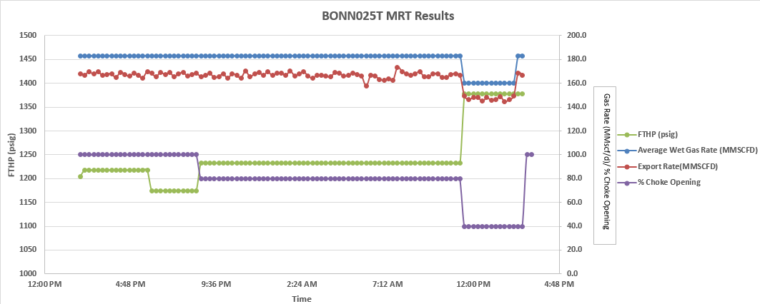

Figure 7: Gas rate, Flowing Tubing Head Pressure and percentage choke opening during the MRT test.

**Condensate/Water Gas Ratio estimation:**

Condensate Gas Ratio for BONN025T was planned to be achieved from the cumulative Liquid of the slug catcher in conjunction with the analysed samples taken during the test. Fig 8a shows the liquid profile with choke opening. Production chemistry analysis of Liquid samples indicates 72% condensate. The Condensate Gas Ratio for BONN025T was achieved by using the Condensate-Water Ratio (CWR) on the cumulative liquid and total volume of gas produced for the MRT flow period. The WGR was also evaluated using the same methodology. The **average CGR for BONN025T is estimated as 0.24 bbl/MMscf and the WGR is 0.09 bbl/MMscf.**

|  |
| --- |
|  |
| Figure 8a: Liquid Gas Ratio profile for BONN025T during MRT |

**Step Rate Interpretation:**

A plot of bottom hole pressure against gas rate was carried out in order to determine the Absolute Open Hole Flow potential of the well and this was compared with bottom hole pressure against rate for the initial Multi rate test carried out on BONN025T before start of production. On the same plot Drawdown squared against gas rate was plotted in order to determine the turbulence at the well completion and compared with initial turbulence of the well. Figure 9 below shows the step rate interpretation of the BONN025T Multi rate Test and comparison with Multi rate test carried out at initial condition.

Figure 9: Step Rate Interpretation for BONN025T including comparison with 2014 MRT and prediction to 2020.

The Flowing Bottom Hole Pressure MRT data analysis in 2014 indicates Absolute Open hole Flow potential (AOF) of XX MMscf/d but current estimate for 2017 Multi rate test is XX MMscf/d. This result is expected due to XXX. This indicates AOF of the Multi rate test using a Test Separator carried out in XXX. A forward estimation of AOF in BONN025T at 2020 gave XX MMscf/d as AOF during late life of the well. The Turbulence comparison between 2014 and 2017 indicates the well was producing with turbulence in 2014 but in 2017 it is currently producing XXXX. This indicates 2017 MRT shows High turbulence, High Permeability formation and low skin which is same with 2014 analysis however the 2014 analysis shows lower skin.

|  |  |
| --- | --- |
|  |  |
| Figure 10a: PROSPER model Inflow Performance Relationship (IPR) matched with Bottom hole pressures from MRT. | Figure 10b: PROSPER model matched with MRT results indicating potential of 74 MMscf/d |

Based in figure 10a and10 b above, Multi Rate Test results was matched to well modelling software (PROSPER). Match indicates Darcy skin was increased by XX% from 2014 to 2017 however actual numbers i.e. Skin in 2014 was XX and skin in 2017 is XX indicates increase in skin from 2014 to 2017. Model also shows Productivity Index of the well in 2017 is PI = XX*10-4 (MMscf/d)/ psig2) while Productivity Index in 2014 was XX*10-4 (MMscf/d)/ psig2).

**Conclusion on BONN025T Multi Rate Test:**

The analysis of Multi Rate Test results indicate Productivity Index did not show significant change in PI from 2014 to 2017. There is drastic AOF change from 2014 to 2017- attributed to …………………………. in 2014. Results indicate higher turbulence in 2017 than 2014- attributed to higher drawdown in 2017 in order to achieve 2014 potential of XX MMscf/d. The well potential of 166 MMscf/d was achieved during the Multi rate Test and this will be carried as the potential of the well.

**Multi rate Test of other 3 gas wells in Bonny node**

Based on learning from Multi rate test results analysis of BONN025T, Multi rate test results of other 3 gas wells in Bonny Node were analyzed. Summary of the analysis BONN026T,027T & 023T are subsequently captured. The step rate analysis for the wells indicate same behavior of high turbulence, High Permeability and low skin just like BONN025T. Details of each well is captured below

**BONN026T:**

BONN026T is one of five wells producing gas from the Bonny M1000M reservoir. Well had a planned initial potential of 100 MMscf/d however it was revised to 55 MMscf/d in 2014. Well achieved 172 MMscf/d during multi rate test at 100% Choke and FTHP of 1218 psig. MRT for this well was carried out on 100%, 80%, 60%, 40% and 20% choke sizes. The FBHPs from FTHP calculation in PROSPER was used to determine the flowing bottom hole pressure from a set of surface conditions i.e. the FTHP, FTHT, Gas rate, Condensate gas rate & Water gas rate (figure 11a). FBHPs for each rate step was estimated using the FBHP from FTHP section of PROSPER. Condensate and water gas ratios were determined using the same methodology used for BONN025T (figure 11b). The **average CGR for BONN026T is estimated as 0.15 bbl/MMscf and the WGR is 0.08 bbl/MMscf.**

Estimated FBHPs were used to construct the Inflow Performance Relationship curve (IPR) by plotting the MRT rates and the Corresponding FBHPs (see figure 11c). The Absolute Open flow potential achieved by this well is XX MMscf/d. The PROSPER well performance model was used to match the maximum rate of XX MMscf/ achieved by the well during the MRT (see figure 11d). The match gave a skin of XX and a productivity index of XX *10-4. Step rate analysis for this well indicates well production behavior is high turbulence, medium skin and producing from a high permeability reservoir.

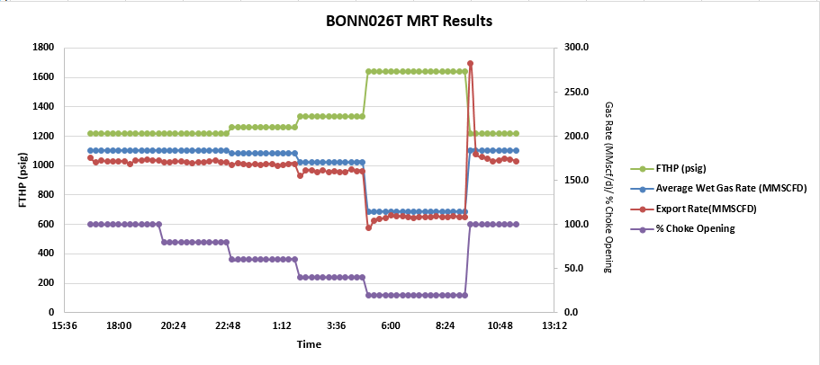

Figure 11a: Gas rate, Flowing Tubing Head Pressure and percentage choke opening

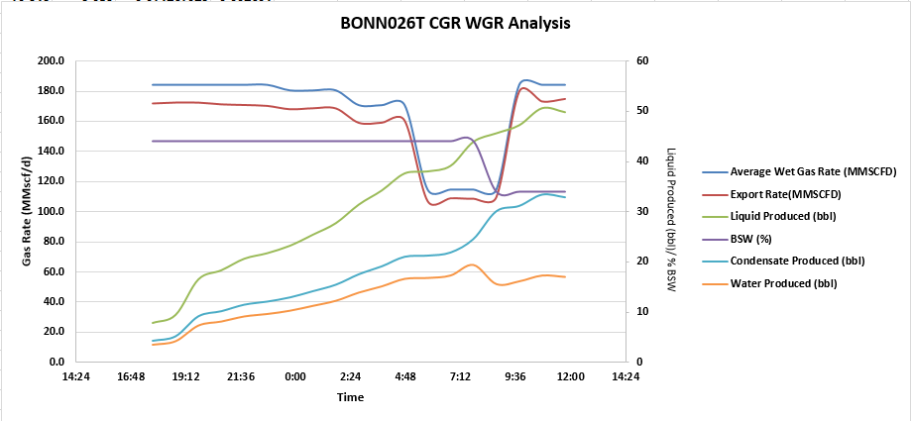

Figure 11b: Liquid Gas Ratio profile for BONN026T during MRT

|  |  |
| --- | --- |
| Figure 11c: IPR matched with FBHP estimated from PROSPER | Figure 11d: Well Model matched with MRT results. |

**BONN027T:**

BONN027T is one of five wells producing gas from the Bonny M1000M reservoir. Well had a planned initial potential of 100 MMscf/d however it was revised to XX MMscf/d in 2014. Well achieved 136 MMscf/d during multi rate test at 100% Choke and FTHP of 1175 psig. MRT for this well was carried out on 100%, 60% and 20% choke sizes. The FBHPs from FTHP calculation in PROSPER was used to determine the flowing bottom hole pressure from a set of surface conditions i.e. the FTHP, FTHT, Gas rate, Condensate gas rate & Water gas rate (figure 12a). FBHPs for each rate step was estimated using the FBHP from FTHP section of PROSPER. Condensate and water gas ratios were determined using the same methodology used for BONN025T (figure 12b). The **average CGR for BONN027T is estimated as 0.08 bbl/MMscf and the WGR is 7.78 bbl/MMscf.**

Estimated FBHPs were used to construct the Inflow Performance Relationship curve (IPR) by plotting the MRT rates and the Corresponding FBHPs (see figure 12c). The Absolute Open flow potential achieved by this well is XX MMscf/d. The PROSPER well performance model was used to match the maximum rate of XX MMscf/ achieved by the well during the MRT (see figure 12d). The match gave a skin of XX and a productivity index of XX *10-4. Step rate analysis for this well indicates well production behavior is high turbulence, medium skin and producing from a high permeability reservoir.

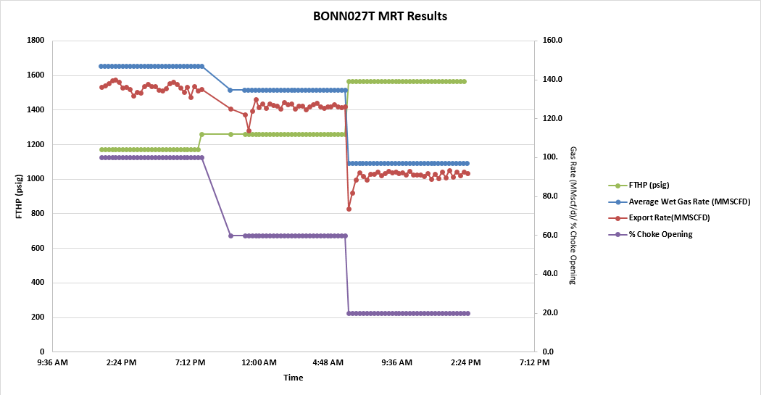

Figure 12a: Gas rate, Flowing Tubing Head Pressure and percentage choke opening

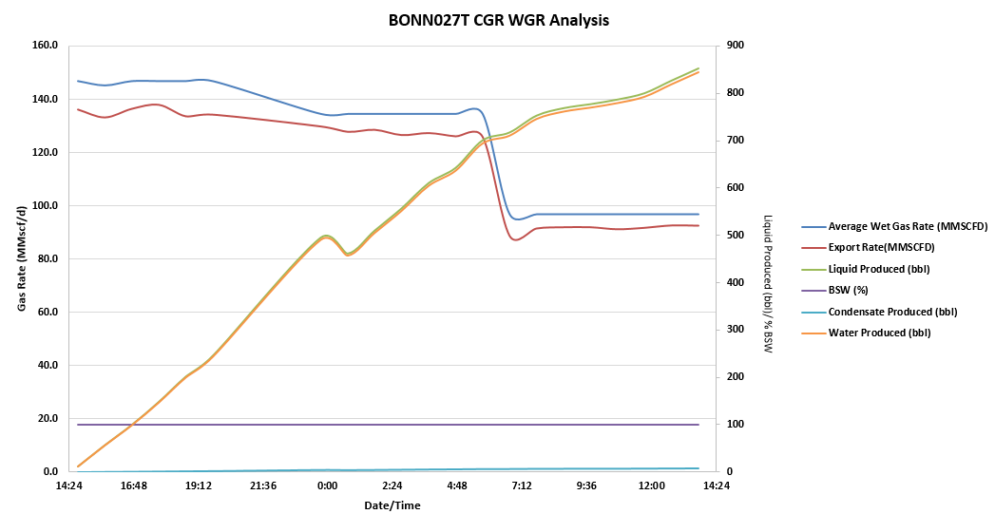

Figure 12b: Liquid Gas Ratio profile for BONN027T during MRT

|  |  |
| --- | --- |
| Figure 12c: IPR matched with FBHP estimated from PROSPER | Figure 12d: Well Model matched with MRT results. |

**BONN023T:**

BONN023T is one of five wells producing gas from the Bonny M1000M reservoir. Well had a planned initial potential of 50 MMscf/d however it was revised to XX MMscf/d in 2014. Well achieved 16 MMscf/d during multi rate test at 100% Choke and FTHP of 1726 psig. MRT via Test by difference with BONN026T had limitations as the control valve for BONN023T (at the manifold) was not working. This limited the test to only 100% choke size. Condensate and water gas ratios were determined using the same methodology used for BONN025T (figure 13a). The **average CGR for BONN023T is estimated as 0.02 bbl/MMscf and the WGR is 1.95 bbl/MMscf.**

Estimated FBHPs were used to construct the Inflow Performance Relationship curve (IPR) by plotting the MRT rates and the Corresponding FBHPs (see figure 13b). The Absolute Open flow potential achieved by this well is XX MMscf/d. The PROSPER well performance model was used to match the maximum rate of XX MMscf/ achieved by the well during the MRT (see figure 13c). The match gave a skin of XX and a productivity index of XX *10-4. Step rate analysis for this well indicates well production behavior is high turbulence, medium skin and producing from a high permeability reservoir.

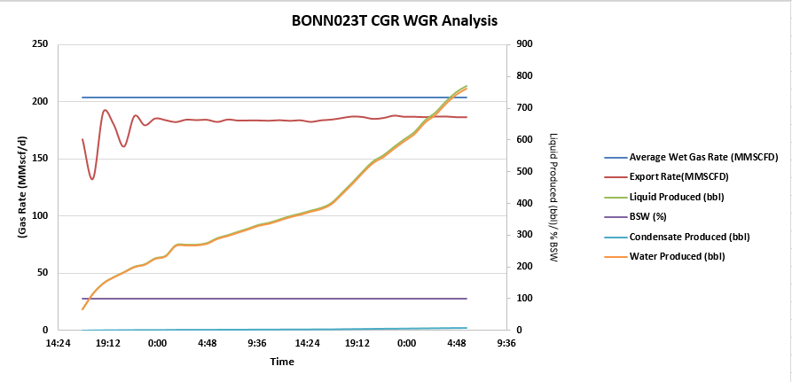

Figure 13a: Liquid Gas Ratio profile for BONN023T during MRT

|  |  |
| --- | --- |
| Figure 13b: IPR matched with FBHP estimated from PROSPER | Figure 13c: Well Model matched with MRT results. |

**Summary of results:**

**Table 1: Summary of Gas potentials from Bonny Node gas wells Multi Rate Tests**

|  |  |  |  |  |  |  |  |
| --- | --- | --- | --- | --- | --- | --- | --- |
| **S/N** | **Conduit** | **EC potential MMscf/d (2016)** | **MRT results MMscf/d (2017)** | **Proposed Potential MMscf/d (2017)** | **Skin** | **Productivity Index**  **(MMscf/d )/ psig2** | **Remarks** |
| 1 | BONN-025T | XX | 168 | 168 | XX | XX *10-4 |  |
| 2 | BONN-026T | XX | 172 | 172 | XX | XX *10-4 |  |
| 3 | BONN-027T | XX | 137 | 137 | XX | XX *10-4 |  |
| 4 | BONN-023T | XX | 16 | 16 | XX | XX *10-4 |  |
| 5 | BONN-029T | XX | YTBD | YTBD | TBA* | TBA* |  |
| 6 | BONN-003T | XX | YTBD | YTBD | TBA* | TBA* |  |

*TBA*- To Be Addressed as tests are conducted in the next available NLNG shutdown window.*

*YTBD – Yet To Be Done*

In summary all wells have ……….skin. HP/LP mode operational conditions has a significant impact on the total deliverability from the BNAG wells……

**Limitations and Recommendations**

To improve the accuracy of this methodology, the following recommendations are made.

|  |  |  |
| --- | --- | --- |
|  | **Limitations** | **Recommendations** |
| 1 | Absence of PDHG on Most Wells | * Conduct wireline surveys to confirm FBHP for selected wells without downhole gauges * Install downhole gauges in wells that are currently without. * Alternatively, integrate SPIDR gauge during MRT exercise. This is dependent on robustness check on its reliability. |
| 2 | Inaccurate CGR & WGR for Wet Systems | * Install a sight glass or an interface level transmitter on the slug catchers to help monitor the changes in water and condensate levels which will improve the accuracy of the method. * Install a 3-phase slug catcher or a 3-phase flow meter if available |

**Key Observations & Recommendations for BNAG operation**

A lot of observations were noted during this pilot initiative of BNAG MRT via the Gas Plant. This includes the following:

* The Automated Choke valves at the manifold for the gas wells require maintenance.
* The design of the Choke valves at the Oloma Manifold area did not show any graduation as it was impossible to know if the choke valves were fully open or closed, the opening of the valve was done based on operator judgement.
* It was not possible to determine the full open status of the choke valves on BONN023T which could have been restricted.BONN023T has the highest manifold pressure during bulk flow, thereby backing out other wells from dumping into the export header.
* There are two operating modes for the gas production: HP and LP.
* The LP mode allows for the wells to dump into the export header line at the manifold.
* The HP mode does not allow BONN029T and BONT03T to dump into the export header.
* The flowmeter at the by-pass line was not working and requires maintenance.

**Conclusion**

Despite limitations, the results of this Multi rate Test are in line with subsurface expectations and they have been used to advise the SPDC Management on the true potentials of these wells and authenticate the gas promises made to the NLNG facility. Hence, the exercise is deemed successful with cost savings of $8mln dollars, zero deferment, zero HSSE exposure to company and personnel.

**Nomenclature**

PDHG: Permanent Down Hole Gauge

CGR: Condensate Gas Ratio

WGR: Water Gas Ratio

GAS PLANT: Central Processing Facility

MRT: Multi Rate Test

AOFP: Absolute Open Hole Flow Potential

LGR: Liquid Gas Ratio

SPDC: Shell Petroleum Development Company of Nigeria

PROSPER: Well performance modelling software

FTHP: Flowing Tubing Head Pressure

FBHP: Flowing Bottom Hole pressure

FTHT: Flowing Tubing Head Temperature

NAG: Non Associated Gas

**References**

1. Sedgwick, A, Obeahon, P, Daodu, O, 2015 Bonny Node MRT Test Programme.
2. Obeahon, P, 2014 Proposed Multi- Rate Testing Procedure.
3. Obeahon, P. P., Daodu, O., Sedgwick A., Okereke, O. 2015 Alternative Approach to Multi-Rate Testing Shell Petroleum Development Company (SPDC).
4. Rawlins, E.L. and Schellhardt, M.A. 1935. Backpressure Data on Natural Gas Wells and Their Application to Production Practices, 7. Monograph Series, U.S. Bureau of Mines
5. K Chu and S Thakur, Amoco Production Co. Modelling of Wellbore Heat Losses in Directional Wells under Changing Injection Conditions, SPE PAPER 22870.